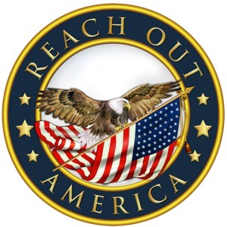

Press Release

Re: Disaster Response for (Community, region)

To whom it may concern,

Reach Out America, an organization founded in 1995, with the goal of serving communities impacted by disaster helping to restore their resilience will be providing non perishable food, water and emergency resources to the communities affected by the recent disaster event. Our distribution center(s) and distribution timers are listed below. Resources are open to the public. Volunteers are needed to help with distribution of supplies. Please contact: First name Last Name at email: Cell: For more information.

Locations

Apostolic Church
1234 First St
Anytown, State Zip
Www.UPCI.org
Contact: Email:
Cell:
Distribution Dates: January 6-12, 2021
Distribution Times
Monday Tuesday. Wednesday Thursday Friday Saturday Sunday
9-5 9-5 9-5 9-5 9-5 9-5 1-5

Distribution will be on the North side of the building, by the covered awning.

Reach Out America provides resources to regain resiliency with a local community, restoring hope to families negatively impacted.

Larry Williamson, President

Reach Out America
A 501c3 Non-Profit Organization
P. O. Box 1234
Sugarland, TX 77478
W. Www.ReachOutAmerica.org
E. Info@reachoutamerica.org

